Home Work 3: Oracle SQL Class

# Instructions

Create the tables for this homework in the Books schema.

**ORDER OF OPERATIONS**

**When creating tables**

a. Create the parent table first (if more than 1 then either one)

b. Create the primary key on the parent table(s)

c. Create the child table

d. Create the primary key on the child table

e. Create the foreign ley on the child that points to the primary key on the parent(s)

**When adding data**

a. Add the parent records first (if more than 1 parent then either one)

b. If more than one parent exists add the next parent record next

c. Then add the child record using the primary key values from parent/parents

**When deleting data**

a. Delete the child record first

b. Then you can delete one or more parents if you need to in whichever order you like

# Homework Music: ER Diagram

Artist is parent to Song

Song is child to Artist

Song is parent to Track

Album is parent to Track

Track is child to Song

Track is child to Album

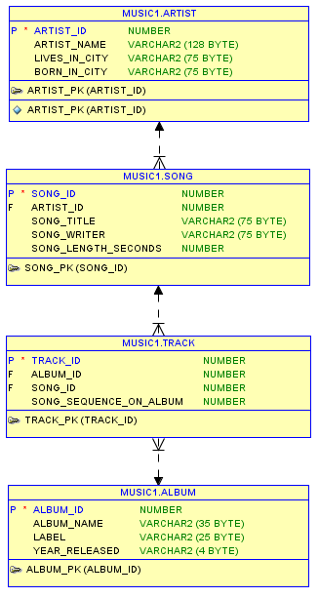

one to many

one to many

one to many



# Homework Music: Confirmation

Create the tables and constraints as discussed above. Insert the data for one of your own albums. Then copy and paste the SQL statements below into SQL developer.

Modify them to run against your own tables if necessary. (if you gave your fields names other than in the spreadsheet)

Create a Microsoft Word document called HW_3_Confirmation.doc. In the word document place the following items:

**-- ---------------------------------------------------**

**-- Homework Music: Confirmation**

**-- ---------------------------------------------------**

1. Screenshot of: **No 1. SQL**

**-- No 1. SQL. List all artist’s names**

**select user, sysdate, artist_name**

**from artist;**

1. Screenshot of: **No 2. SQL**

**-- ---------------------------------------------------**

**-- No 2. SQL. List song titles, artist's name for all songs -- and sort by song title**

**select user, sysdate, artist_name, song_title**

**from artist ar, song s**

**where ar.artist_id = s.artist_id**

**order by song_title;**

1. Screenshot of: **No 3. SQL**

**-- ---------------------------------------------------**

**-- No 3. SQL. List album name and song titles for**

**-- all albums and sort by album_name**

**select user, sysdate, album_name, song_title**

**from song s, track t, album al**

**where s.song_id = t.song_id**

**and t.album_id = al.album_id**

**order by album_name;**

1. Screenshot of: **No 4. SQL**

**-- ---------------------------------------------------**

**-- No. 4. You are trying to decide if you want to**

**-- buy another album from the artist you added.**

**-- So list artist_name, album_name, song_title for**

**-- all songs by your artist.**

**select user, sysdate, artist_name, album_name, song_title**

**from artist ar, song s, track t, album al**

**where ar.artist_id = s.artist_id**

**and s.song_id = t.song_id**

**and t.album_id = al.album_id**

**and artist_name = 'Put Your Artists Name Here';**

**-- ---------------------------------------------------**

NOTE: A screen capture should contain (1) the connections panel, (2) the actual connection used (top right drop down), the (3) SQL statement and (4) the result set.

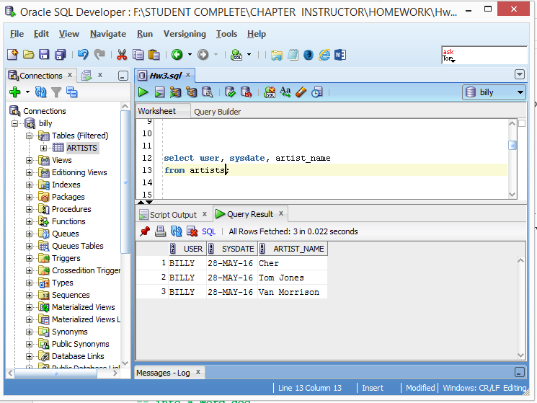

**1**

**2**

**3**

**4**